

**NURO Analysis Guide**

Table of Contents

**Overview2**

**Login3**

**Analyze Boilers4**

Initializing Analysis4

Available Boilers5

Selecting Time Intervals6

Error Summary7

Test Cases8

Generating Graphs9

**Graph Features10**

Crosshair and Tooltips10

Dataset Popups11

Remove/Add Datasets12

Zoom and Pan13

**Mobile Devices14**

Sidebar Navigation14

Graph Options15

Hover Features16

**Explanation of Tests17**

**Overview**

**Purpose**: NURO Analysis is a web app that uses the data from NURO Connect to identify error points and develop solutions based on specific tests.

**Features**:

* Access to data for all boilers and sites
* Execute tests to find errors in equipment
* Produce solutions to improve efficiency and productivity of boilers
* Generate graphs comparing relevant data points
* Analyze data from specific time periods
* Connections with NURO Connect

**Login**

**Credentials**: Use the same email and password as NURO Connect.

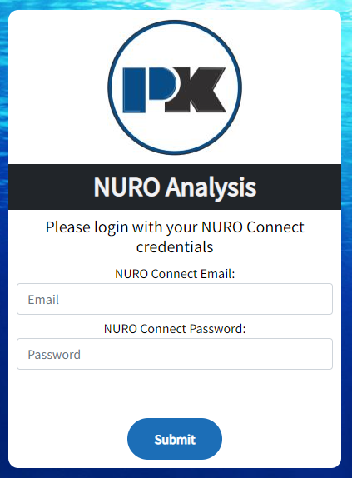

**Analyze Boilers**

**Initializing Analysis**: From the homepage, press the blue “Conduct Analysis” button to open the Analyze Boilers page. From any page in the app, press “Analyze Boilers” on the sidebar to open the Analyze Boilers page.

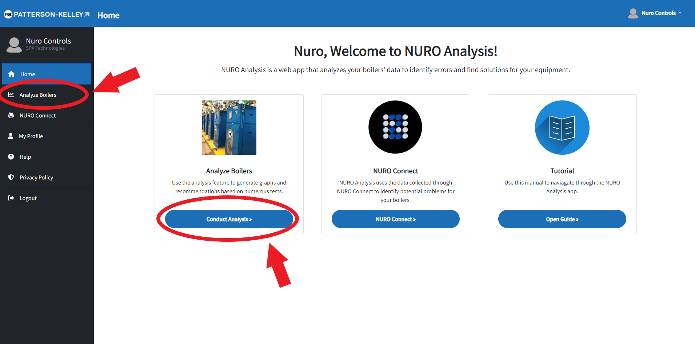

**Available Boilers**: Once the Available Boilers page is open, select a boiler to analyze. Press the blue “Run Diagnostics” button under the desired boiler.

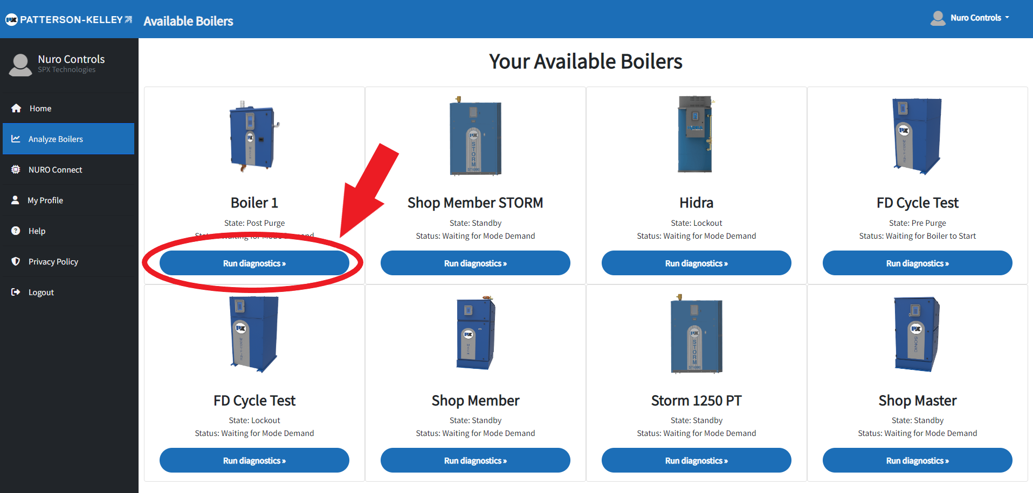

**Selecting Time Intervals**: After the “Run Diagnostics” button is pressed, the Diagnostics page will open. There will be a form to select a start time, end time, and time interval. The start time must be before the end time, and NURO Connect must have been connected during the time period. Press the blue “Submit” button when the times have been entered.

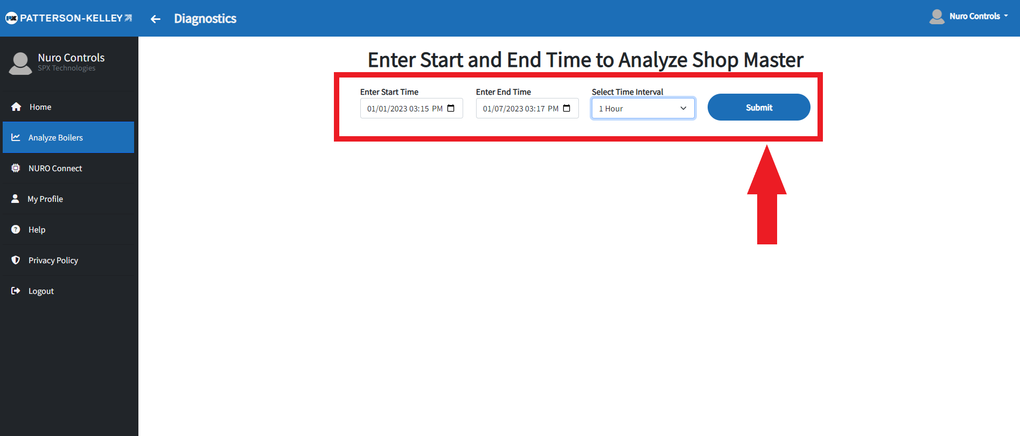

**Error Summary**: Once the time interval is submitted and the data is collected, a popup will open showing a summary of the test results. This will give suggestions on how to eliminate future errors, improve efficiency, and find potential solutions. Press the “x” in the top right corner to close the popup. Press the blue “Open Summary” button to reopen the popup. The Yellow Errors are not shown by default. Press the “Yellow Errors” button to show these messages.

* **Red Errors**: These are from tests that have a failure rate of at least 25%. They are important to fix as they are the main sources of error for the boiler.
* **Yellow Errors**: These are from tests that have a failure rate under 25% but over 0%. They are less urgent but can identify the impact of red errors on the performance of other parts of the boiler and prevent further equipment error if monitored.

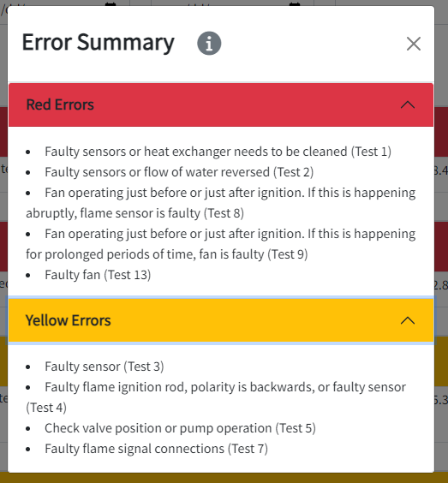

**Test Cases**: There are numerous tests to analyze the performance of the boiler. They compare specific datasets to determine if all parts of the boiler are working efficiently.

* **Red Tests**: These tests failed over 25% of the time and are the main source of inefficiency in the boiler.
* **Yellow Tests**: These tests had failed under 25% but did not pass 100%. They are often the byproduct of other red tests or are trending towards red. Check these tests to prevent future performance loss.
* **Green Tests**: These tests had a 0% error.

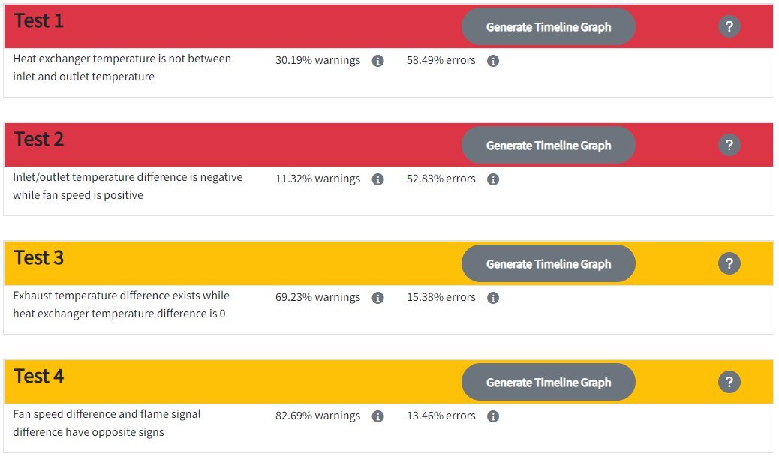

**Generating Graphs**: For each of the tests, there is a grey “Generate Timeline Graph” button. Press the button for the desired test to open its graph. Press the grey “Close Timeline Graph” to close the graph. When the timeline graph is open, press the grey “Generate Binary Graph” to show the pass/fail/warning graph to easily see the error and warning statuses. Press the “Close Binary Graph” to hide the binary graph. Press the grey question mark button for an explanation of all the graph features

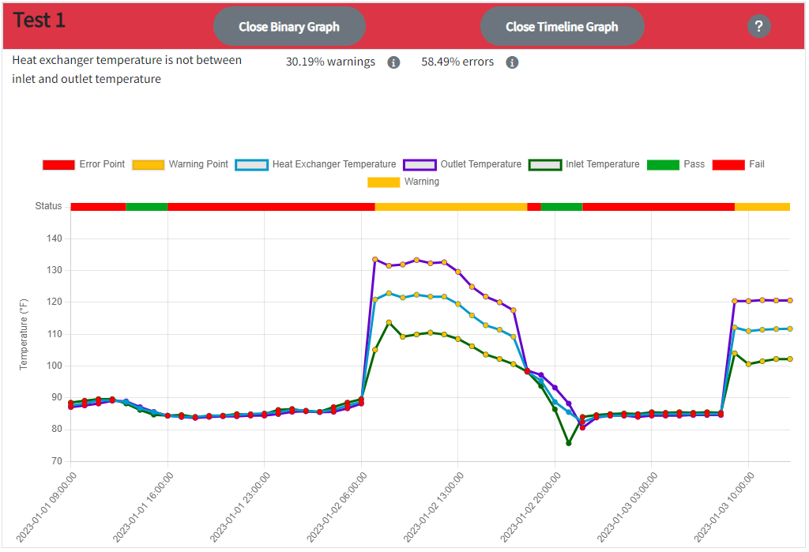

**Graph Features**

**Crosshair and Tooltips**: Hover over the graph to show a crosshair that highlights the data points for the selected date and time. This will also display a tooltip that shows the labels, values, and colors for the datasets and the test status for that point.

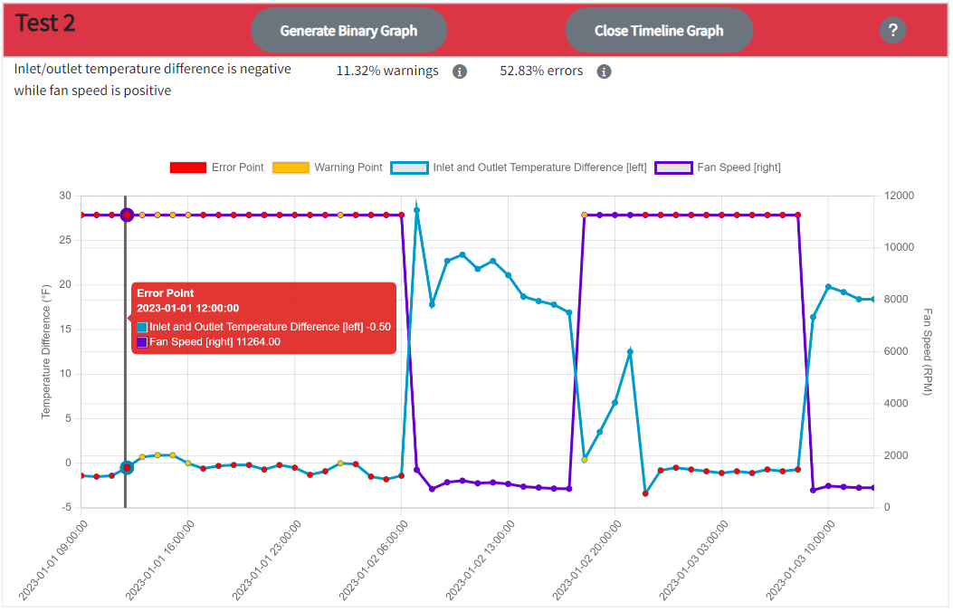

**Dataset Popups**: Hover the dataset names on the legend to show the popup information for the specific dataset. Information includes error point conditions, warning point thresholds, and axis usage.

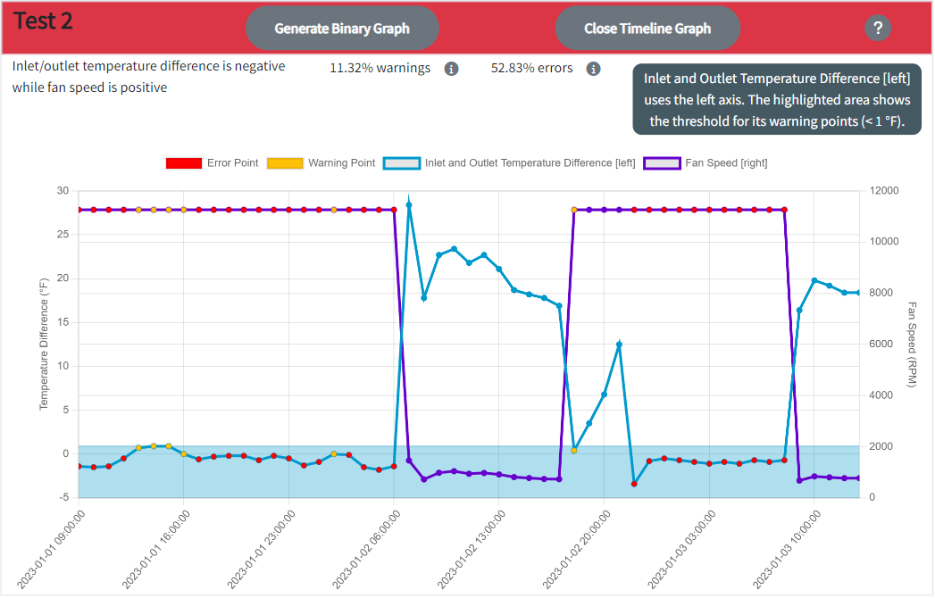

**Remove/Add Datasets**: On the graph legend, press a dataset’s name to hide its points. Press the dataset’s name again to add the points back to the graph. This is useful to remove warning points to only show error points, vice versa.

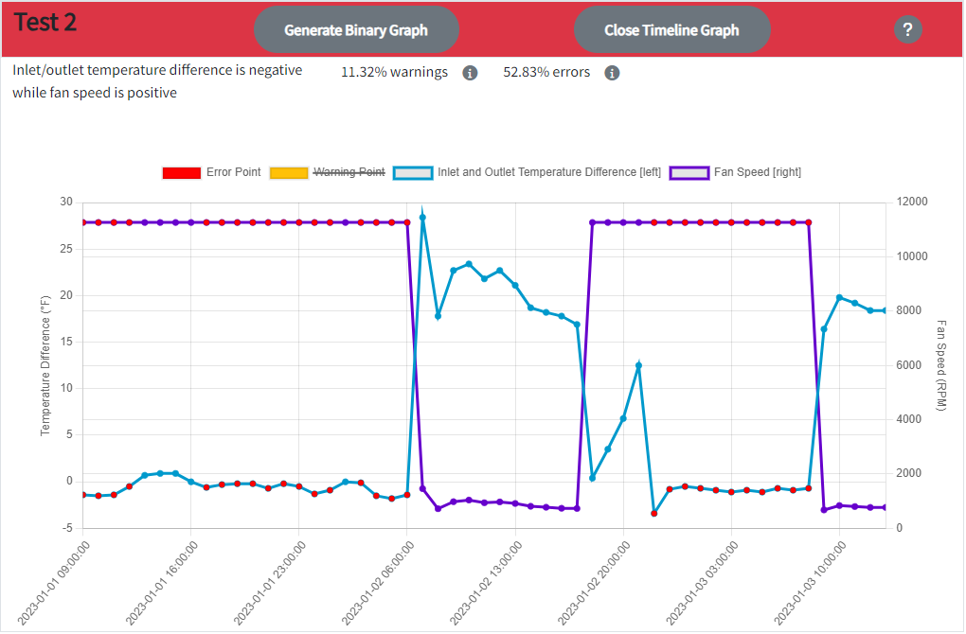

**Zoom and Pan**: To zoom in, drag the mouse over the desired values or scroll the mouse wheel. To pan across values while zoomed in, press CTRL and use mouse to drag to desired values. Press the grey reset button to revert to the original graph.

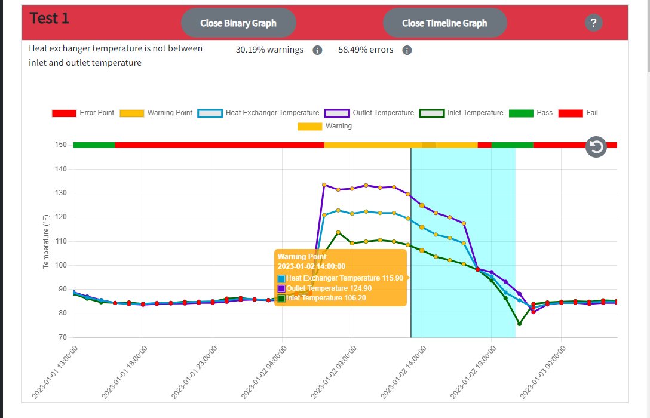

**Mobile Devices**

**Sidebar Navigation**: Press the grey button in the top left corner to open the sidebar. The sidebar will help navigate around the site.

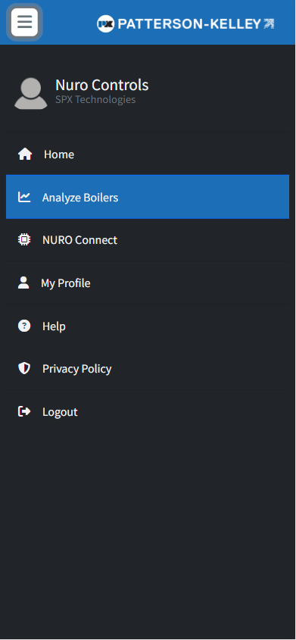

**Graph Options**:

* **Graph Generation**: Press the grey “Options” button of a specific test to open the graph dropdown. The “Generate Timeline Graph” option opens the test graph. The “Close Timeline Graph” option closes the test graph. The “Generate Binary Graph” option opens the pass/fail/warning graph to easily see when the data fails the test. The “Close Binary Graph” option closes the pass/fail/warning graph.
* **Zoom and Pan**: To zoom in/out, pinch the graph. To pan, drag finger across the graph.

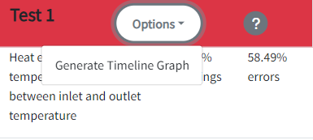

**Hover Features**: All hover features are accessible for mobile through touch. Help popups can be opened with one press. The graph crosshair can be displayed by pressing the desired point. Dataset popups and warning thresholds can be shown by double clicking the legend label. One click would still remove/add the dataset.

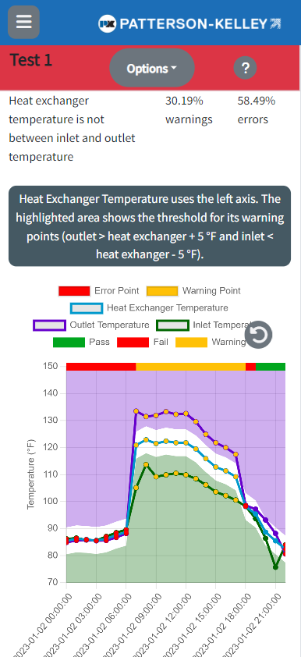

**Explanation of Tests**

* **Test 1**: Heat exchanger temperature is not between inlet and outlet temperature
  + **Causes**: faulty sensors or dirty heat exchanger
  + **Importance**: heat exchanger heats the water from the inlet and releases it at the outlet; needs to occur regularly to produce heat efficiently
* **Test 2**: Fan is on and inlet temperature is higher than outlet temperature
  + **Causes**: faulty sensors or flow of water reversed
  + **Importance**: outlet temperature must be higher than inlet temperature to produce heat; if the fan is on, the unit is on, confirming the faulty equipment
* **Test 3**: Heat exchanger temperature is constant while exhaust temperature is not constant
  + **Causes**: faulty sensor
  + **Importance**: unit is running or exhaust gases are coming from another boiler
* **Test 4**: Fan speed is increasing while flame signal is decreasing, vice versa
  + **Causes**: faulty flame ignition rod, polarity is backwards, or faulty sensor
  + **Importance**: unit is not igniting at the correct time
* **Test 5**: Outlet temperature is higher than inlet temperature and flame signal is 0
  + **Causes**: incorrect valve position and/or pump operation
  + **Importance**: water is passing through the exchanger while unit is turned off or the exchanger is flowing through an off piece of equipment
* **Test 6**: Fan is off and outlet temperature is higher than inlet temperature
  + **Causes**: faulty fan signal and/or fan failed
  + **Importance**: fan is off when the unit is running, not allowing the proper cooling to occur
* **Test 7**: Firing rate is increasing while flame signal is decreasing, vice versa
  + **Causes**: faulty flame signal connections
  + **Importance**: unit is not igniting correctly
* **Test 8**: Fan is on and firing rate is 0
  + **Causes**: fan is operating just before or just after ignition; if occurring abruptly, flame sensor is faulty, causing flame ignition failure
  + **Importance**: unit is not igniting correctly
* **Test 9**: Fan is on and flame signal is 0
  + **Causes**: fan is operating just before or just after ignition; if occurring for long periods of time, fan is faulty
  + **Importance**: unit is not igniting correctly
* **Test 10**: Positive firing rate and flame signal is 0
  + **Causes**: faulty flame sensor; incorrect wiring of ignition equipment
  + **Importance**: unit is firing at the incorrect time
* **Test 11**: Flame signal changes drastically while fan is off
  + **Causes**: ignition equipment is faulty, dirty, or has bad connection; check ignition rod and sensor
  + **Importance**: unit is not igniting correctly
* **Test 12**: Duration for flame signal is less than 10 minutes at a time
  + **Causes**: boiler is short cycling; unit is operating too quickly and/or firing time is too short
  + **Importance**: short cycling reduces efficiency
* **Test 13**: Fan is on and flame signal is 0 for over 90 seconds at a time
  + **Causes**: fan is acting erratically
  + **Importance**: unit is not igniting correctly; fan is not cooling properly